**Artist Opportunity**

**Participate in the *Annual Friends’ Expo* at Ceres Gallery**

**July 22 - August 16, 2025**

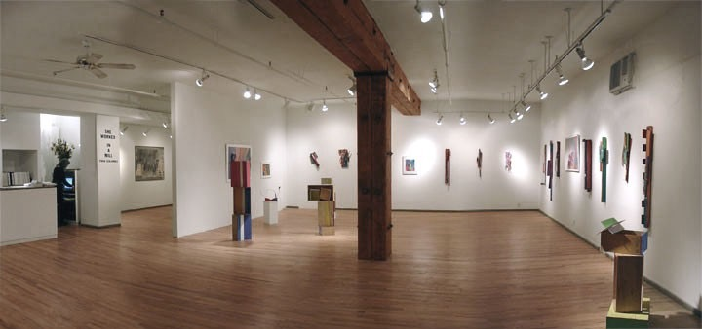

This exhibition is a thank you to ARTIST FRIENDS from Ceres members for a donation of $200. As an **ARTIST FRIEND**, you will be invited to exhibit a wall piece or sculpture (size limitation) plus a small bonus art work.

If you would like to participate in the *Annual Friends’ Expo*, please send Ceres your donation of $200 and a completed donation form and become an **ARTIST FRIEND**. The Friends’ Exhibition is not juried. Ceres is a not-for-profit gallery and your donation will help us continue providing a forum for the enrichment and growth of artists.

Your name will appear on the Friends’ List on the Ceres website [***http://www*.*ceresgallery.org***](http://www.ceresgallery.org/)**(click on *Be A Friend*)** and be in Ceres’ Registry Book with your Artist Statement and your resume.

**Exhibition: July 22nd - August 16th 2025**

Opening Reception: Thurs., **July 24,** **6:00-8:00pm**

***Entry Deadline June13, 2025*** to be on the card

Ceres is looking forward to our ***Annual Friends’ Expo,*** which will take place **July 22 – August 16, 2025.**

With an opening reception for the artists and their guests on **Thursday, July 24, from 6:00 – 8:00 PM.**

We look forward to your participation.

***Go t***[***o www.CeresGallery.org***](http://www.CeresGallery.org/) ***- Be A Friend - for full details and application***

*Ceres Gallery 547 West 27th Street, Suite 201 New York New York 10001. 212-947-6100*

*E-Mail:* [*art@ceresgallery.org*](mailto:art@ceresgallery.org) *- Website:* [www.ceresgallery.org](http://www.ceresgallery.org) *& Find us on* Face*book*

**2025 Friends Donation Form**

Yes! I want to make a difference and support interest and accessibility to new art. Please enroll me as a:

$200 ARTIST FRIEND: **G*roup Exhibition Opportunity***, inclusion in yearly Artist Information Registry book (open to public for reference). Receive show announcements and invitations to all exhibition opening receptions and inclusion in *Friends of Ceres* listing in the brochure and website.

Name________________________________________________________________________________

Address_______________________________________________________________________________

City ________________________________________________ State________________ Zip _________

Phone (day) _________________________ Phone (evening) _______________________________

E-mail address___________________________________________________________

Website ________________________________________________________________

TOTAL AMOUNT ENCLOSED ________________________________________________

All donations are tax-deductible to the fullest extent of the law.

Please make checks payable to Ceres.

Mail checks to: Ceres, 547 West 27th Street, Suite 201, New York, NY 10001.

For further information, please call Stefany Benson, Director:

Phone: 212.947-6100,

Email: art@ceresgallery.org